NAME: ________________________________

DATE: _________________________________

**the four SEASONS**



______________________________ ______________________________

______________________________ ______________________________

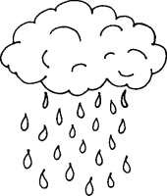**the WEATHER**

______________________________ ______________________________

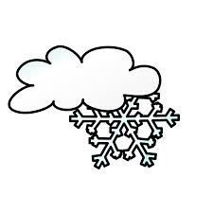______________________________ ______________________________

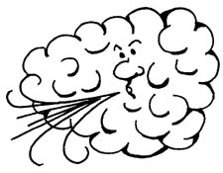______________________________ ______________________________

______________________________

______________________________

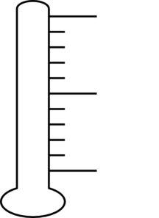 -5 C 14 C 18 C 30 C

_______________ _______________ ______________ ________________

*MAGIC BOOK 2, unit 3 WORKSHEET 32.3.10 seasons & weather*