Name: _________________________________________________
Date: __________________________________________________

Pupils’ Book UNIT 3
- Page 34: MY COUNTRY
Answer the following questions:
- What is the name of your country? _____________________________________
- What is the name of its capital city? ____________________________________
- Write the names of 10 European countries: (Pupil’s Book pages 162-163 and a map of Europe) ___________________________________________________________________________________________________________________________________________________________________________________________________
- Write the parts of the United Kingdom: (Pupil’s Book page 161)
____________________________________________________________________________________________________________________________________
- Write the names of the continents: (Pupil’s Book pages 164-165)
______________________________________________________________________________________________________________________________________________________________________________________________________

B. Write the 13 districts of Greece:
__________________________________________________________________________________________________________________________________________________________________________________________________________________________________________________________________________________________________________________________________________
__________________________________________________________________

C. Write 10 Cyclades islands:
____________________________________________________________________________________________________________________________________________________________________________________________________________
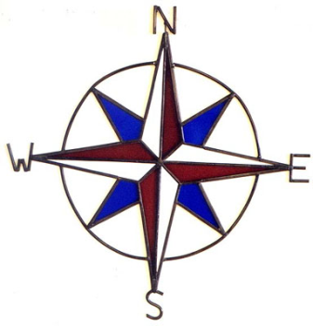W=west (δύση), N=north (βορράς), S=south (νότος), Ε=east (ανατολή)

CLASS 4 UNIT 3 lesson 1 WORKSHEET 4.3.1
D. Where are your classmates from? Write about 5 of them:
e.g. Andrew is from Oxford, England.
name town country
- _______________________________________________________________
- _______________________________________________________________
- _______________________________________________________________
- _______________________________________________________________
- _______________________________________________________________

E. What colour are the FLAGS of the countries on Pupil’s Book page 37:

- The flag of Greece is______________ and _______________________.
- _________________________________________________________
- _________________________________________________________
- _________________________________________________________
- _________________________________________________________
- _________________________________________________________

F. COPY and LEARN: copy twice (2 φορές) and learn

Tell us about your country. My country is Greece.
____________________________________________________________________________________________________________________

Where is it? It’s in the South-East of Europe.
____________________________________________________________________________________________________________________

It’s a beautiful country with mountains, rivers and beaches.
____________________________________________________________________________________________________________________
The Greek capital city is Athens. I live on Ios island.
____________________________________________________________________________________________________________________

