NAME: ________________________
DATE: ________________________

PUPIL’S BOOK page 25 Compare the school on this page with your school:
In Great Britain they wear __________________________________________
In Greece we wear _______________________________________________
In Great Britain they have/use _______________________________________
In Greece we have/use ____________________________________________
In Great Britain they must raise their hand to speak. They must listen to the teacher. They must be quiet in class.
In Greece we __________________________________________________
___________________________________________________________
In Great Britain their teacher _______________________________________
In Greece our teacher ____________________________________________

PUPIL’S BOOK page 26 Use the menu on page 26 to act out this dialogue:
A: Can I have a ____________________________, please?
B: Here you are!
A: Thank you. How much is it?
B: It’s _________ pence.
A: Here you are!
B: Thank you!

PUPIL’S BOOK page 29 Write, draw and colour!
HEALTHY and UNHEALTHY DIET
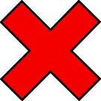

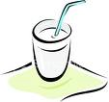
Milk is healthy! Drink milk!
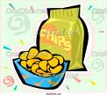
Barbeque-flavoured crisps are unhealthy!
Don’t eat them!

POSITIVE and NEGATIVE FEELINGS
Class 5 PUPIL’S BOOK unit 2, lesson 1, pages 25, 26, 29 worksheet 5.2.1

