NAME : _______________________________
DATE : _______________________________

GRAMMAR : PAST CONTINUOUS
Verb: look
affirmative interrogative negative
I was looking was I looking ? I was not looking
you were looking were you looking ? you were not looking
he was looking was he looking ? he was not looking
she was looking was she looking ? she was not looking
it was looking was it looking ? it was not looking
we were looking were we looking ? we were not looking
you were looking were you looking ? you were not looking
they were looking were they looking ? they were not looking

verb: play
AFFIRMATIVE | INTERROGATIVE | NEGATIVE

A. Describe what you were doing:
e.g. I was sleeping. I was having lunch.
- 07:55________________________________________________________
- 09:50________________________________________________________
- 14:00________________________________________________________
- 18:00________________________________________________________
- 21:00_________________________________________________________

B. Describe what your friends and family were doing:
e.g. My mother was listening to music. My friends were playing in the playground.
- 07:55________________________________________________________
- 09:50________________________________________________________
- 14:00________________________________________________________
- 18:00________________________________________________________
- 21:00____________________________________________________

C. Describe what the pupils were doing when the teacher was not in the classroom:
e.g. Some boys were running. A girl was singing.
- ___________________________________________________________
- ___________________________________________________________
- ___________________________________________________________
- ___________________________________________________________
- ___________________________________________________________

CLASS 6 UNIT 4 GRAMMAR: PAST CONTINUOUS WORKSHEET 6.4.3

D. Describe what the pupils were doing during the break:
e.g. Some boys were running. A girl was eating.
- ___________________________________________________________
- ___________________________________________________________
- ___________________________________________________________
- ___________________________________________________________
- ___________________________________________________________

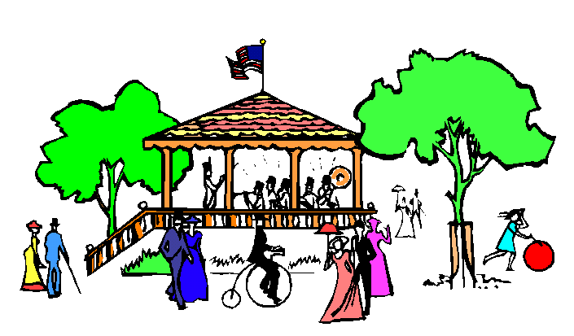
E. Describe the picture: What is happening? What are the people doing? (Present Continuous)
- ____________________________________________________________________________________
- ____________________________________________________________________________________
- ____________________________________________________________________________________
- ____________________________________________________________________________________
- ____________________________________________________________________________________
- ____________________________________________________________________________________
- ____________________________________________________________________________________
- ____________________________________________________________________________________
- ____________________________________________________________________________________
- ____________________________________________________________________________________

F. Describe the picture: What was happening? What were the people doing? (Past Continuous)
- ____________________________________________________________________________________
- ____________________________________________________________________________________
- ____________________________________________________________________________________
- ____________________________________________________________________________________
- ____________________________________________________________________________________
- ____________________________________________________________________________________
- ____________________________________________________________________________________
- ____________________________________________________________________________________
- ____________________________________________________________________________________
- ____________________________________________________________________________________

