Name: ______________________________
Colouring:
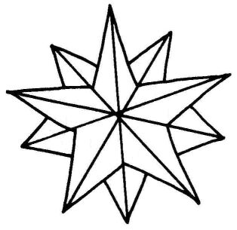
CHRISTMAS DECORATION
Colour the star:
one= red
two= blue
three= yellow
four=green
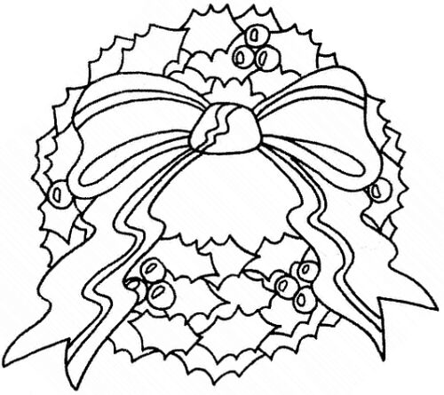
Colour the wreath:
five= red
six: yellow
seven: light green
eight: dark green

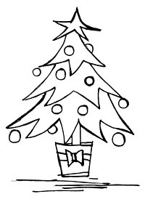
Colour the Christmas tree:
star: yellow
balls: red
pot: blue
ribbon: purple
tree: green

Name: ______________________________
CHRISTMAS vocabulary
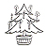Christmas tree
Santa Claus / Father Christmas
angel
present
Christmas star
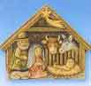
manger
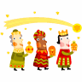the three wise men
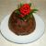traditional English Christmas pudding
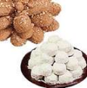traditional Greek sweets

CHRISTMAS & NEW YEAR WISHES:
WE WISH YOU
A MERRY CHRISTMAS and A HAPPY NEW YEAR!
HAPPY CHRISTMAS HOLIDAYS!

