NAME : _______________________________

DATE : _______________________________

FAMILY & FRIENDS

Απάντησε στις ερωτήσεις:

V X

Yes , I am . No , I`m not .

Yes , you are . No , you aren`t .

Yes , he is . No , he isn`t .

Yes , she is . No , she isn`t .

Yes , it is . No , it isn`t .

1. Are you a boy ? ____________________
2. Are you a girl ? ____________________
3. Am I a teacher ? ____________________
4. Am I a pupil ? ____________________
5. Is your father tall ? ____________________
6. Is your father short ? ____________________
7. Is your mother tall ? ____________________
8. Is your mother short ? ____________________
9. Is your bag big ? ____________________
10. Is your bag small ? ____________________
11. Are you Greek ? ____________________
12. Are you English ? ____________________
13. Am I your mother ? ____________________
14. Am I your teacher ? ____________________
15. Is your friend tall ? ____________________
16. Is your friend short ? ____________________
17. Is your teacher Greek ? ____________________
18. Is your teacher English ? ____________________

Let’s play BINGO!

happy, sad, scared, angry, hungry, brave, tall, short, big, small, old, new

Από τις παραπάνω λέξεις διάλεξε και γράψε 3 φορές από 5 για να παίξουμε 3 φορές BINGO!

BINGO 1

1________ 2 ________ 3 ________ 4 ________ 5 ________

BINGO 2

1________ 2 ________ 3 ________ 4 ________ 5 ________

BINGO 3

1________ 2 ________ 3 ________ 4 ________ 5 ________

*MAGIC BOOK UNIT 2 LESSON 2 WORKSHEET 3.2.2*

ADJECTIVES – ΕΠΙΘΕΤΑ

Γράψε κάθε επίθετο στο σωστό σχήμα:

white tall happy big grey angry blue green scared short brown black new little small yellow sad orange old red young brave hungry pink purple

1. feelings = συναισθήματα

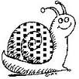 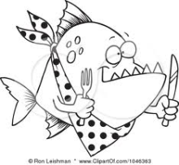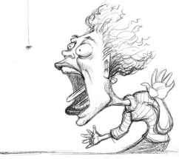 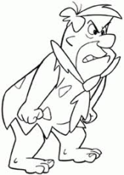 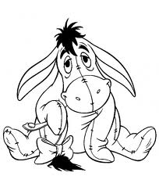 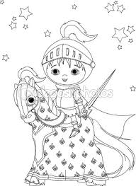

_____________ ____________ _____________ ____________ ____________ ______________

1. colours = χρώματα



1. opposites = αντίθετα

