NAME: ________________________________

DATE: _________________________________

**Unit 4: THE WIND AND THE SUN “the season game”**

Lesson 3 – Page 61 - Copy the dialogue from your book:

Picture 1

* _______________________________________________________________
* _______________________________________________________________

Picture 2

* _______________________________________________________________
* _______________________________________________________________
* _______________________________________________________________

Picture 3

* _______________________________________________________________

_______________________________________________________________

* _______________________________________________________________

Picture 4

* _______________________________________________________________

_______________________________________________________________

* _______________________________________________________________

Picture 5

* _______________________________________________________________
* _______________________________________________________________

_______________________________________________________________

Picture 6

* _______________________________________________________________
* _______________________________________________________________

*MAGIC BOOK unit 4 lesson 3 WORKSHEET 3.4.3*

**the four SEASONS**



______________________________ ______________________________

______________________________ ______________________________

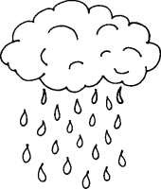**the WEATHER**

______________________________ ______________________________

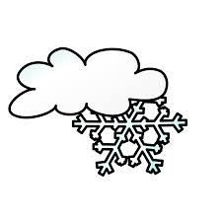______________________________ ______________________________

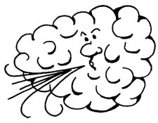______________________________ ______________________________

______________________________

______________________________

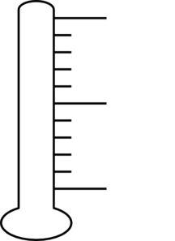 -5 C 14 C 18 C 30 C

_______________ _______________ ______________ ________________