NAME: ______________________________________
DATE: ______________________________________

The two main British Isles are:
a) _________________________________________________
b) _________________________________________________

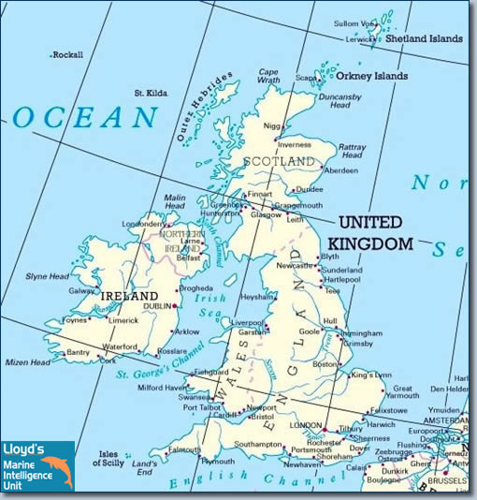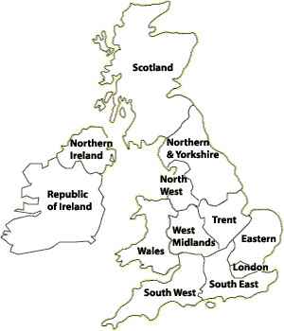

Colour the map of the United Kingdom:
England: red, Wales: orange, Scotland: blue, Northern Ireland: green

- THE UNITED KINGDOM

The island of Great Britain is made up of:
a) _________________________________________________
b) _________________________________________________
c) _________________________________________________

The United Kingdom:
a) _________________________________________________
b) _________________________________________________
c) _________________________________________________
d) _________________________________________________

The population of the United Kingdom is _________________________________________ million people.
The capital of the United Kingdom is ______________________________________.
The population of London is _________________________________________ million people.
The national flower of ________________________________ is the rose (τριαντάφυλλο).
The national flower of ________________________________ is the daffodil (ασφόδελος).
The national flower of ________________________________ is the thistle (γαϊδουράγκαθο).

CLASS 5 UNIT 1 page 22 WORKSHEET 5.1.3
- THE REPUBLIC OF IRELAND (EIRE)

The Republic of Ireland (Eire) is the southern part of the island of Ireland.

The population of the Republic of Ireland (Eire) is _____________________________________ million people.
The capital of the Republic of Ireland (Eire) is ______________________________________.
The population of Dublin is _________________________________________ million people.
The national flower of___________________________________________ is the shamrock. (τριφύλλι)

- GREECE
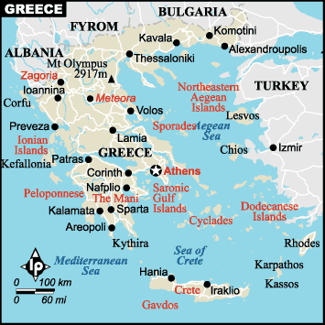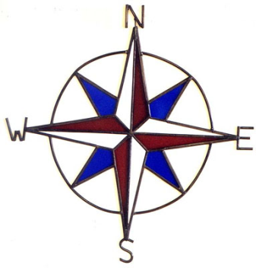
W=west (δύση), N=north (βορράς), S=south (νότος), Ε=east (ανατολή)

The population of Greece is _________________________________________ million people.
The capital of Greece is ______________________________________.
The population of Athens is _________________________________________ million people.

Cyclades are made up of about______________________ big and ___________________________ small islands:

- We live on _________________island.
- Naxos & Paros are at the _________________ , Sikinos & Folegandros are at the ____________________, Santorini is at the ______________ and Iraklia, Scinoussa and Amorgos are at the_____________ of Ios.
- Its population is ________________________________________ people.
- Its capital is ________________________________.
- The flower of Ios is ___________________________________.

Στις Κυκλάδες ανήκουν τα παρακάτω νησιά, τα οποία κατά σειρά μεγέθους είναι: Νάξος, Άνδρος, Πάρος, Τήνος, Μήλος, Κέα, Αμοργός, Ίος, Κύθνος, Μύκονος, Σύρος, Θήρα ή Σαντορίνη, Σέριφος, Σίφνος, Σίκινος, Ανάφη, Κίμωλος, Αντίπαρος, Φολέγανδρος, Μακρόνησος, Ηρακλειά, Γυάρος, Πολύαιγος, Κέρος, Ρήνεια, Δονούσα, Θηρασία, Αντίμηλος, Δεσποτικό, Σχοινούσα, Άνω Κουφονήσι, Κάτω Κουφονήσι και Δήλος.
Επίσης ο νομός Κυκλάδων περιλαμβάνει και πολυάριθμα μικρότερα νησιά καθώς και συστάδες νησιών όπως η συστάδα Αντιπάρου, οι νησίδες Μακάρες, η Άνυδρος (ή Αμοργοπούλα), το Ασπρονήσι, η Νέα Καμένη, η Παλαιά Καμένη, η Ασκανιά, η Εσχάτη, η Χριστιανή, η Νικουριά, η Καρδιώτισσα, η Κιτριανή, η Σεριφοπούλα, το Γλαρονήσι, το Ρευματονήσι, το Αβολαδονήσι, το Τραγονήσι, τα Αβελονήσια και το Σχινονήσι.

